

Technical Design

Document

v1.0

Jeff Yang

Contents

**1.0** **Introduction** 3

1.1 Purpose 3

**2.0** **Design** 4

Application tree 4

**3.0** **User stories** 5

As a User… 5

As an Admin… 5

**4.0 Implementation Specifics** 6

4.1 Languages and Frameworks 6

JavaScript 6

React Framework 6

Redux 6

# **Introduction**

## Purpose

The system will be designed to provide an authentication service where users can log in and …

# **Design**

## Application tree

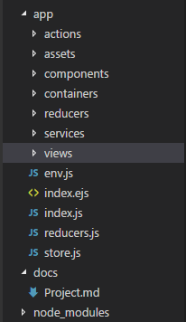The application is split into many sub directories.

* Actions contain the actions that Redux uses.
* Assets contain the images and other hypermedia objects.
* Components contain the presentational layer
* Containers contain the functional layer connected to these presentational layers
* Reducers contain the reducers that Redux uses
* Services contain all external network requests

# **User stories**

## As a User…

* I should be able to sign in to the site (Once an admin has created an account for me)

## As an Admin…

* I should be able to sign in to the site (with my email and password that was provided)
* I should be able to register users for the site
* I should be able to view all users registered for the site
* I should be able to unregister users from the site

# **4.0 Implementation Specifics**

## 4.1 Languages and Frameworks

### JavaScript

This web application will be using JavaScript for the bulk of the work.

### React Framework

Component-based JavaScript framework which make it easy to create interactive UI’s.

### Redux

Open source JavaScript library designed for managing application state.

### Materialize-css

Lightweight CSS framework used to make the site look nice.